**LEMBAR SOAL TEST TULIS HARIAN**

Mata Pelajaran : Pendidikan Pancasila Ulangan Ke : 3

Bab : 3. Sopan Hari / tanggal :

Jumlah Soal : 10 Soal Kelas / Semester : I (Satu) / I (Satu)

Isilah titik-titik dibawah ini dengan jawaban yang benar!

1. Sikap yang tepat saat menyapa teman adalah ………………………
2. Rasa menghargai dapat menciptakan ………………………….
3.  Saat berkenalan kita menyebutkan …………………………kita.
4. Perbedaan dalam keluarga harus di …………………………………..
5. Berteman adalah perbuatan yang ………………………..
6. Setiap orang mempunyai kekurangan dan …………………………………



1. Gambar disamping adalah contoh perbuatan yang ……………
2. Saat pagi hari bertemu bu guru kita mengucapkan selamat ……………………………
3. Saat ada orang tua menyeberang jalan kita harus …………………………
4. Doni berkulit putih, Dea berkulit hitam namun mereka harus tetap ……………….

Kunci Jawaban : 1. Ramah 6. kelebihan

2.kerukunan 7. tercela

3. nama 8. pagi

4. dihargai 9. membantunya

5. terpuji 10 berteman

Penilaian : Benar X 10 = 100

Disupervisi tanggal ………… Tenggerwetan, ………….2023

Mengetahui

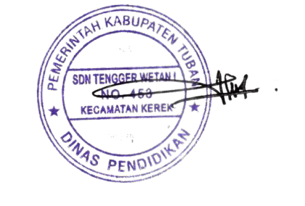

Pengawas Sekolah TK, SD, SDLB Kepala Sekolah Guru Kelas I (Satu)



**JATMIKA, S.Pd** **IMAM MURDIYANTO, S.Pd.SD** **RATNA WAHYUNI, S.Pd**

NIP. 19640416 198504 1 1002 NIP. 19801014 200801 1 009 NIP. 19851021 201903 2 006

**ANALISIS SUMATIF LINGKUP MATERI**

Mata Pelajaran : Pendidikan Pancasila Ulangan Ke : 3

Bab : 3. Sopan Hari / tanggal :

Jumlah Soal : 10 Soal Kelas / Semester : I (Satu) / I (Satu)

|  |  |  |  |  |  |  |  |  |  |  |  |  |
| --- | --- | --- | --- | --- | --- | --- | --- | --- | --- | --- | --- | --- |
| **NO** | **NAMA SISWA** | **BUTIR SOAL ISIAN** | | | | | | | | | | **NILAI TUJUAN PEMBELAJARAN** |
| 1 | 2 | 3 | 4 | 5 | 6 | 7 | 8 | 9 | 10 |
| 1. | Ahmad Beryl Subkan | 1 | 1 | 1 | 1 | 1 | 1 | 1 | 1 | 1 | 0 | 90 |
| 2. | Ahmad Izam Alhamdan | 1 | 1 | 1 | 1 | 0 | 1 | 1 | 1 | 1 | 0 | 80 |
| 3. | Anda Gian Pratama | 1 | 1 | 1 | 1 | 1 | 1 | 1 | 0 | 1 | 0 | 80 |
| 4. | Aulia Beby | 1 | 1 | 1 | 1 | 1 | 1 | 1 | 1 | 1 | 0 | 90 |
| 5. | Erdiano Utama | 1 | 1 | 1 | 1 | 1 | 1 | 1 | 0 | 1 | 0 | 80 |
| 6. | Hanafi Adam Pratama | 1 | 1 | 1 | 1 | 1 | 1 | 0 | 1 | 1 | 0 | 80 |
| 7. | Jefi Alif Febbiyanti | 0 | 1 | 1 | 1 | 1 | 0 | 1 | 1 | 1 | 0 | 70 |
| 8. | Jumfikri | 1 | 0 | 1 | 1 | 1 | 1 | 1 | 1 | 1 | 0 | 80 |
| 9. | Lisa Aktanesia | 1 | 1 | 1 | 1 | 1 | 1 | 0 | 1 | 1 | 0 | 80 |
| 10. | Mohamad Daril Adikri | 1 | 1 | 1 | 1 | 1 | 1 | 1 | 1 | 1 | 0 | 90 |
| 11. | Mohamad Robil Alamaulil | 1 | 1 | 1 | 1 | 1 | 1 | 1 | 0 | 1 | 0 | 80 |
| 12. | Muhammad Justin Gilbert | 1 | 1 | 1 | 1 | 1 | 1 | 0 | 1 | 0 | 0 | 70 |
| 13. | Nova Italia | 1 | 1 | 1 | 1 | 1 | 0 | 1 | 1 | 1 | 0 | 80 |
| 14. | Rafila Firda Ferdiyansah | 1 | 1 | 1 | 1 | 1 | 1 | 0 | 1 | 1 | 0 | 80 |
| 15. | Redi Fransisko | 1 | 1 | 0 | 1 | 0 | 1 | 1 | 1 | 1 | 0 | 70 |
| 16. | Rif’an Febrianto | 1 | 0 | 1 | 1 | 1 | 1 | 1 | 0 | 1 | 0 | 70 |
| 17. | Roef Ahmat Firmansyah | 0 | 1 | 1 | 0 | 1 | 1 | 1 | 1 | 1 | 0 | 70 |
| 18. | Sabilal Khoir | 1 | 1 | 1 | 1 | 1 | 1 | 1 | 1 | 1 | 0 | 90 |
| 19. | Selvi | 1 | 0 | 1 | 1 | 1 | 0 | 1 | 1 | 1 | 0 | 70 |
| 20. | Siti Aisah | 1 | 1 | 1 | 0 | 1 | 1 | 0 | 1 | 1 | 0 | 70 |
| 21. | Ummi Kulsum | 1 | 1 | 1 | 1 | 1 | 1 | 1 | 0 | 1 | 0 | 80 |
| 22. | Verdiano Elvan Alteza | 1 | 1 | 1 | 1 | 0 | 1 | 1 | 1 | 1 | 0 | 80 |
| 23. | Willi Febriyo | 1 | 1 | 1 | 1 | 1 | 1 | 0 | 1 | 1 | 0 | 80 |
| 24 | Willona Selsa Putri | 1 | 1 | 1 | 1 | 1 | 1 | 1 | 1 | 1 | 0 | 90 |

Tenggerwetan, ………….2023

Mengetahui

Kepala Sekolah Guru Kelas I (Satu)

**IMAM MURDIYANTO, S.Pd.SD** **RATNA WAHYUNI, S.Pd**

NIP. 19801014 200801 1 009 NIP. 19851021 201903 2 006

**LEMBAR TINDAK LANJUT HASIL PENILAIAN DAN JENIS TES : ULANGAN PERBAIKAN**

Mata Pelajaran : Pendidikan Pancasila Ulangan Ke : 3

Bab : 3. Sopan Hari / tanggal :

Jumlah Soal : 10 Soal Kelas / Semester : I (Satu) / I (Satu)

|  |  |  |  |  |  |  |  |  |  |  |  |  |
| --- | --- | --- | --- | --- | --- | --- | --- | --- | --- | --- | --- | --- |
| **NO** | **NAMA SISWA** | **BUTIR SOAL ISIAN** | | | | | | | | | | **NILAI TUJUAN PEMBELAJARAN** |
| 1 | 2 | 3 | 4 | 5 | 6 | 7 | 8 | 9 | 10 |
| 1. | Ahmad Beryl Subkan |  |  |  |  |  |  |  |  |  |  |  |
| 2. | Ahmad Izam Alhamdan |  |  |  |  |  |  |  |  |  |  |  |
| 3. | Anda Gian Pratama |  |  |  |  |  |  |  |  |  |  |  |
| 4. | Aulia Beby |  |  |  |  |  |  |  |  |  |  |  |
| 5. | Erdiano Utama |  |  |  |  |  |  |  |  |  |  |  |
| 6. | Hanafi Adam Pratama |  |  |  |  |  |  |  |  |  |  |  |
| 7. | Jefi Alif Febbiyanti |  |  |  |  |  |  |  |  |  |  |  |
| 8. | Jumfikri |  |  |  |  |  |  |  |  |  |  |  |
| 9. | Lisa Aktanesia |  |  |  |  |  |  |  |  |  |  |  |
| 10. | Mohamad Daril Adikri |  |  |  |  |  |  |  |  |  |  |  |
| 11. | Mohamad Robil Alamaulil |  |  |  |  |  |  |  |  |  |  |  |
| 12. | Muhammad Justin Gilbert |  |  |  |  |  |  |  |  |  |  |  |
| 13. | Nova Italia |  |  |  |  |  |  |  |  |  |  |  |
| 14. | Rafila Firda Ferdiyansah |  |  |  |  |  |  |  |  |  |  |  |
| 15. | Redi Fransisko |  |  |  |  |  |  |  |  |  |  |  |
| 16. | Rif’an Febrianto |  |  |  |  |  |  |  |  |  |  |  |
| 17. | Roef Ahmat Firmansyah |  |  |  |  |  |  |  |  |  |  |  |
| 18. | Sabilal Khoir |  |  |  |  |  |  |  |  |  |  |  |
| 19. | Selvi |  |  |  |  |  |  |  |  |  |  |  |
| 20. | Siti Aisah |  |  |  |  |  |  |  |  |  |  |  |
| 21. | Ummi Kulsum |  |  |  |  |  |  |  |  |  |  |  |
| 22. | Verdiano Elvan Alteza |  |  |  |  |  |  |  |  |  |  |  |
| 23. | Willi Febriyo |  |  |  |  |  |  |  |  |  |  |  |
| 24 | Willona Selsa Putri |  | E:\FILE RATNA-ZIE\SCAN TTD + STEMPEL.png |  |  |  |  |  |  |  |  |  |

Mengetahui : Mengetahui :

Pengawas Sekolah TK, SD, SDLB Kepala Sekolah Guru Kelas I (Satu)

**JATMIKA, S.Pd** **IMAM MURDIYANTO, S.Pd.SD** **RATNA WAHYUNI, S.Pd**

NIP. 19640416 198504 1 1002 NIP. 19801014 200801 1 009 NIP. 19851021 201903 2 006

**LEMBAR TINDAK LANJUT HASIL PENILAIAN DAN JENIS TES : ULANGAN PENGAYAAN**

Mata Pelajaran : Pendidikan Pancasila Ulangan Ke : 3

Bab : 3. Sopan Hari / tanggal :

Jumlah Soal : 10 Soal Kelas / Semester : I (Satu) / I (Satu)

|  |  |  |  |  |  |  |  |  |  |  |  |  |
| --- | --- | --- | --- | --- | --- | --- | --- | --- | --- | --- | --- | --- |
| **NO** | **NAMA SISWA** | **BUTIR SOAL ISIAN** | | | | | | | | | | **NILAI TUJUAN PEMBELAJARAN** |
| 1 | 2 | 3 | 4 | 5 | 6 | 7 | 8 | 9 | 10 |
| 1. | Ahmad Beryl Subkan |  |  |  |  |  |  |  |  |  |  |  |
| 2. | Ahmad Izam Alhamdan |  |  |  |  |  |  |  |  |  |  |  |
| 3. | Anda Gian Pratama |  |  |  |  |  |  |  |  |  |  |  |
| 4. | Aulia Beby |  |  |  |  |  |  |  |  |  |  |  |
| 5. | Erdiano Utama |  |  |  |  |  |  |  |  |  |  |  |
| 6. | Hanafi Adam Pratama |  |  |  |  |  |  |  |  |  |  |  |
| 7. | Jefi Alif Febbiyanti |  |  |  |  |  |  |  |  |  |  |  |
| 8. | Jumfikri |  |  |  |  |  |  |  |  |  |  |  |
| 9. | Lisa Aktanesia |  |  |  |  |  |  |  |  |  |  |  |
| 10. | Mohamad Daril Adikri |  |  |  |  |  |  |  |  |  |  |  |
| 11. | Mohamad Robil Alamaulil |  |  |  |  |  |  |  |  |  |  |  |
| 12. | Muhammad Justin Gilbert |  |  |  |  |  |  |  |  |  |  |  |
| 13. | Nova Italia |  |  |  |  |  |  |  |  |  |  |  |
| 14. | Rafila Firda Ferdiyansah |  |  |  |  |  |  |  |  |  |  |  |
| 15. | Redi Fransisko |  |  |  |  |  |  |  |  |  |  |  |
| 16. | Rif’an Febrianto |  |  |  |  |  |  |  |  |  |  |  |
| 17. | Roef Ahmat Firmansyah |  |  |  |  |  |  |  |  |  |  |  |
| 18. | Sabilal Khoir |  |  |  |  |  |  |  |  |  |  |  |
| 19. | Selvi |  |  |  |  |  |  |  |  |  |  |  |
| 20. | Siti Aisah |  |  |  |  |  |  |  |  |  |  |  |
| 21. | Ummi Kulsum |  |  |  |  |  |  |  |  |  |  |  |
| 22. | Verdiano Elvan Alteza |  |  |  |  |  |  |  |  |  |  |  |
| 23. | Willi Febriyo |  |  |  |  |  |  |  |  |  |  |  |
| 24 | Willona Selsa Putri |  |  |  |  |  |  |  |  |  |  |  |



Mengetahui : Mengetahui :

Pengawas Sekolah TK, SD, SDLB Kepala Sekolah Guru Kelas I (Satu)

**JATMIKA, S.Pd** **IMAM MURDIYANTO, S.Pd.SD** **RATNA WAHYUNI, S.Pd**

NIP. 19640416 198504 1 1002 NIP. 19801014 200801 1 009 NIP. 19851021 201903 2 006

**LEMBAR SOAL TEST TULIS HARIAN**

Mata Pelajaran : Bahasa Indonesia Ulangan Ke : 3

Bab : 3. Awas Kuman! Hari / tanggal :

Jumlah Soal : 10 Soal Kelas / Semester : I (Satu) / I (Satu)

Isilah titik-titik dibawah ini dengan jawaban yang benar!

1. Saat batuk dan pilek sebaiknya memakai ………………………
2. Tangan kotor jadi sarang ………………………….



1. Membuang sampah harus di …………………………
2. Suku kata awal pada kata **kelapa** adalah …………………………………..
3. Kata **kutu** terdiri ……………………….. huruf.
4. Cuci tangan sebaiknya dilakukan sebelum …………………………………



1. Gambar disamping adalah contoh makanan yang ………
2. Binatang yang suka makan wortel adalah ……………………………
3. Makanan yang kotor dapat menyebabkan sakit …………………………
4. Alat untuk membersihkan debu yaitu ……………………………….

Kunci Jawaban : 1. masker 6. makan

2. kuman 7. Tidak sehat

3. tempat sampah 8. kelinci

4. ke 9. perut

5. 4 10 kemoceng

Penilaian : Benar X 10 = 100

Disupervisi tanggal ………… Tenggerwetan, ………….2023

Mengetahui



Pengawas Sekolah TK, SD, SDLB Kepala Sekolah Guru Kelas I (Satu)



**JATMIKA, S.Pd** **IMAM MURDIYANTO, S.Pd.SD** **RATNA WAHYUNI, S.Pd**

NIP. 19640416 198504 1 1002 NIP. 19801014 200801 1 009 NIP. 19851021 201903 2 006

**ANALISIS SUMATIF LINGKUP MATERI**

Mata Pelajaran : Bahasa Indonesia Ulangan Ke : 3

Bab : 3. Awas Kuman! Hari / tanggal :

Jumlah Soal : 10 Soal Kelas / Semester : I (Satu) / I (Satu)

|  |  |  |  |  |  |  |  |  |  |  |  |  |
| --- | --- | --- | --- | --- | --- | --- | --- | --- | --- | --- | --- | --- |
| **NO** | **NAMA SISWA** | **BUTIR SOAL ISIAN** | | | | | | | | | | **NILAI TUJUAN PEMBELAJARAN** |
| 1 | 2 | 3 | 4 | 5 | 6 | 7 | 8 | 9 | 10 |
| 1. | Ahmad Beryl Subkan | 1 | 1 | 1 | 1 | 1 | 1 | 1 | 1 | 1 | 0 | 90 |
| 2. | Ahmad Izam Alhamdan | 1 | 1 | 1 | 1 | 0 | 1 | 1 | 1 | 1 | 0 | 80 |
| 3. | Anda Gian Pratama | 1 | 1 | 1 | 1 | 1 | 1 | 1 | 0 | 1 | 0 | 80 |
| 4. | Aulia Beby | 1 | 1 | 1 | 1 | 1 | 1 | 1 | 1 | 1 | 0 | 90 |
| 5. | Erdiano Utama | 1 | 1 | 1 | 1 | 1 | 1 | 1 | 0 | 1 | 0 | 80 |
| 6. | Hanafi Adam Pratama | 1 | 1 | 1 | 1 | 1 | 1 | 0 | 1 | 1 | 0 | 80 |
| 7. | Jefi Alif Febbiyanti | 0 | 1 | 1 | 1 | 1 | 0 | 1 | 1 | 1 | 0 | 70 |
| 8. | Jumfikri | 1 | 0 | 1 | 1 | 1 | 1 | 1 | 1 | 1 | 0 | 80 |
| 9. | Lisa Aktanesia | 1 | 1 | 1 | 1 | 1 | 1 | 0 | 1 | 1 | 0 | 80 |
| 10. | Mohamad Daril Adikri | 1 | 1 | 1 | 1 | 1 | 1 | 1 | 1 | 1 | 0 | 90 |
| 11. | Mohamad Robil Alamaulil | 1 | 1 | 1 | 1 | 1 | 1 | 1 | 0 | 1 | 0 | 80 |
| 12. | Muhammad Justin Gilbert | 1 | 1 | 1 | 1 | 1 | 1 | 0 | 1 | 0 | 0 | 70 |
| 13. | Nova Italia | 1 | 1 | 1 | 1 | 1 | 0 | 1 | 1 | 1 | 0 | 80 |
| 14. | Rafila Firda Ferdiyansah | 1 | 1 | 1 | 1 | 1 | 1 | 0 | 1 | 1 | 0 | 80 |
| 15. | Redi Fransisko | 1 | 1 | 0 | 1 | 0 | 1 | 1 | 1 | 1 | 0 | 70 |
| 16. | Rif’an Febrianto | 1 | 0 | 1 | 1 | 1 | 1 | 1 | 0 | 1 | 0 | 70 |
| 17. | Roef Ahmat Firmansyah | 0 | 1 | 1 | 0 | 1 | 1 | 1 | 1 | 1 | 0 | 70 |
| 18. | Sabilal Khoir | 1 | 1 | 1 | 1 | 1 | 1 | 1 | 1 | 1 | 0 | 90 |
| 19. | Selvi | 1 | 0 | 1 | 1 | 1 | 0 | 1 | 1 | 1 | 0 | 70 |
| 20. | Siti Aisah | 1 | 1 | 1 | 0 | 1 | 1 | 0 | 1 | 1 | 0 | 70 |
| 21. | Ummi Kulsum | 1 | 1 | 1 | 1 | 1 | 1 | 1 | 0 | 1 | 0 | 80 |
| 22. | Verdiano Elvan Alteza | 1 | 1 | 1 | 1 | 0 | 1 | 1 | 1 | 1 | 0 | 80 |
| 23. | Willi Febriyo | 1 | 1 | 1 | 1 | 1 | 1 | 0 | 1 | 1 | 0 | 80 |
| 24 | Willona Selsa Putri | 1 | 1 | 1 | 1 | 1 | 1 | 1 | 1 | 1 | 0 | 90 |



Tenggerwetan, ………….2023

Mengetahui

Kepala Sekolah Guru Kelas I (Satu)

**IMAM MURDIYANTO, S.Pd.SD** **RATNA WAHYUNI, S.Pd**

NIP. 19801014 200801 1 009 NIP. 19851021 201903 2 006

**LEMBAR TINDAK LANJUT HASIL PENILAIAN DAN JENIS TES : ULANGAN PERBAIKAN**

Mata Pelajaran : Bahasa Indonesia Ulangan Ke : 3

Bab : 3. Awas Kuman! Hari / tanggal :

Jumlah Soal : 10 Soal Kelas / Semester : I (Satu) / I (Satu)

|  |  |  |  |  |  |  |  |  |  |  |  |  |
| --- | --- | --- | --- | --- | --- | --- | --- | --- | --- | --- | --- | --- |
| **NO** | **NAMA SISWA** | **BUTIR SOAL ISIAN** | | | | | | | | | | **NILAI TUJUAN PEMBELAJARAN** |
| 1 | 2 | 3 | 4 | 5 | 6 | 7 | 8 | 9 | 10 |
| 1. | Ahmad Beryl Subkan |  |  |  |  |  |  |  |  |  |  |  |
| 2. | Ahmad Izam Alhamdan |  |  |  |  |  |  |  |  |  |  |  |
| 3. | Anda Gian Pratama |  |  |  |  |  |  |  |  |  |  |  |
| 4. | Aulia Beby |  |  |  |  |  |  |  |  |  |  |  |
| 5. | Erdiano Utama |  |  |  |  |  |  |  |  |  |  |  |
| 6. | Hanafi Adam Pratama |  |  |  |  |  |  |  |  |  |  |  |
| 7. | Jefi Alif Febbiyanti |  |  |  |  |  |  |  |  |  |  |  |
| 8. | Jumfikri |  |  |  |  |  |  |  |  |  |  |  |
| 9. | Lisa Aktanesia |  |  |  |  |  |  |  |  |  |  |  |
| 10. | Mohamad Daril Adikri |  |  |  |  |  |  |  |  |  |  |  |
| 11. | Mohamad Robil Alamaulil |  |  |  |  |  |  |  |  |  |  |  |
| 12. | Muhammad Justin Gilbert |  |  |  |  |  |  |  |  |  |  |  |
| 13. | Nova Italia |  |  |  |  |  |  |  |  |  |  |  |
| 14. | Rafila Firda Ferdiyansah |  |  |  |  |  |  |  |  |  |  |  |
| 15. | Redi Fransisko |  |  |  |  |  |  |  |  |  |  |  |
| 16. | Rif’an Febrianto |  |  |  |  |  |  |  |  |  |  |  |
| 17. | Roef Ahmat Firmansyah |  |  |  |  |  |  |  |  |  |  |  |
| 18. | Sabilal Khoir |  |  |  |  |  |  |  |  |  |  |  |
| 19. | Selvi |  |  |  |  |  |  |  |  |  |  |  |
| 20. | Siti Aisah |  |  |  |  |  |  |  |  |  |  |  |
| 21. | Ummi Kulsum |  |  |  |  |  |  |  |  |  |  |  |
| 22. | Verdiano Elvan Alteza |  |  |  |  |  |  |  |  |  |  |  |
| 23. | Willi Febriyo |  |  |  |  |  |  |  |  |  |  |  |
| 24 | Willona Selsa Putri |  | E:\FILE RATNA-ZIE\SCAN TTD + STEMPEL.png |  |  |  |  |  |  |  |  |  |

Mengetahui : Mengetahui :

Pengawas Sekolah TK, SD, SDLB Kepala Sekolah Guru Kelas I (Satu)

**JATMIKA, S.Pd** **IMAM MURDIYANTO, S.Pd.SD** **RATNA WAHYUNI, S.Pd**

NIP. 19640416 198504 1 1002 NIP. 19801014 200801 1 009 NIP. 19851021 201903 2 006

**LEMBAR TINDAK LANJUT HASIL PENILAIAN DAN JENIS TES : ULANGAN PENGAYAAN**

Mata Pelajaran : Bahasa Indonesia Ulangan Ke : 3

Bab : 3. Awas Kuman! Hari / tanggal :

Jumlah Soal : 10 Soal Kelas / Semester : I (Satu) / I (Satu)

|  |  |  |  |  |  |  |  |  |  |  |  |  |
| --- | --- | --- | --- | --- | --- | --- | --- | --- | --- | --- | --- | --- |
| **NO** | **NAMA SISWA** | **BUTIR SOAL ISIAN** | | | | | | | | | | **NILAI TUJUAN PEMBELAJARAN** |
| 1 | 2 | 3 | 4 | 5 | 6 | 7 | 8 | 9 | 10 |
| 1. | Ahmad Beryl Subkan |  |  |  |  |  |  |  |  |  |  |  |
| 2. | Ahmad Izam Alhamdan |  |  |  |  |  |  |  |  |  |  |  |
| 3. | Anda Gian Pratama |  |  |  |  |  |  |  |  |  |  |  |
| 4. | Aulia Beby |  |  |  |  |  |  |  |  |  |  |  |
| 5. | Erdiano Utama |  |  |  |  |  |  |  |  |  |  |  |
| 6. | Hanafi Adam Pratama |  |  |  |  |  |  |  |  |  |  |  |
| 7. | Jefi Alif Febbiyanti |  |  |  |  |  |  |  |  |  |  |  |
| 8. | Jumfikri |  |  |  |  |  |  |  |  |  |  |  |
| 9. | Lisa Aktanesia |  |  |  |  |  |  |  |  |  |  |  |
| 10. | Mohamad Daril Adikri |  |  |  |  |  |  |  |  |  |  |  |
| 11. | Mohamad Robil Alamaulil |  |  |  |  |  |  |  |  |  |  |  |
| 12. | Muhammad Justin Gilbert |  |  |  |  |  |  |  |  |  |  |  |
| 13. | Nova Italia |  |  |  |  |  |  |  |  |  |  |  |
| 14. | Rafila Firda Ferdiyansah |  |  |  |  |  |  |  |  |  |  |  |
| 15. | Redi Fransisko |  |  |  |  |  |  |  |  |  |  |  |
| 16. | Rif’an Febrianto |  |  |  |  |  |  |  |  |  |  |  |
| 17. | Roef Ahmat Firmansyah |  |  |  |  |  |  |  |  |  |  |  |
| 18. | Sabilal Khoir |  |  |  |  |  |  |  |  |  |  |  |
| 19. | Selvi |  |  |  |  |  |  |  |  |  |  |  |
| 20. | Siti Aisah |  |  |  |  |  |  |  |  |  |  |  |
| 21. | Ummi Kulsum |  |  |  |  |  |  |  |  |  |  |  |
| 22. | Verdiano Elvan Alteza |  |  |  |  |  |  |  |  |  |  |  |
| 23. | Willi Febriyo |  |  |  |  |  |  |  |  |  |  |  |
| 24 | Willona Selsa Putri |  | E:\FILE RATNA-ZIE\SCAN TTD + STEMPEL.png |  |  |  |  |  |  |  |  |  |

Mengetahui : Mengetahui :

Pengawas Sekolah TK, SD, SDLB Kepala Sekolah Guru Kelas I (Satu)

**JATMIKA, S.Pd** **IMAM MURDIYANTO, S.Pd.SD** **RATNA WAHYUNI, S.Pd**

NIP. 19640416 198504 1 1002 NIP. 19801014 200801 1 009 NIP. 19851021 201903 2 006

**LEMBAR SOAL TEST TULIS HARIAN**

Mata Pelajaran : Bahasa Indonesia Ulangan Ke : 4

Bab : 4. Aku Bisa! Hari / tanggal :

Jumlah Soal : 10 Soal Kelas / Semester : I (Satu) / I (Satu)

Isilah titik-titik dibawah ini dengan jawaban yang benar!

1. Huruf vokal pada **lalat** adalah ………………………
2. Gajah bergerak dengan cara ………………………….



1. Mobil itu mogok harus di…………………………
2. **b-a-l-e-h** Susunan kata yang benar adalah………………………………..
3. Suku awal kata **mobil** adalah ………………………..
4. Binatang yang badanya besar telinganya lebar adalah ………………………

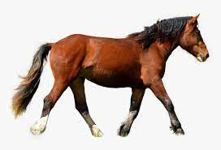

1. Binatang disamping bergerak dengan cara………
2. Burung dapat terbang karena memiliki ……………………………
3. Bebek memiliki ………………………… kaki.
4. Tiga huruf berurutan setelah huruf k adalah ……………………………….

Kunci Jawaban : 1. A 6. gajah

2. berjalan 7. berjalan

3. dorong 8. sayap

4. lebah 9. 2

5. mo 10 l, m, n

Penilaian : Benar X 10 = 100

Disupervisi tanggal ………… Tenggerwetan, ………….2023

Mengetahui



Pengawas Sekolah TK, SD, SDLB Kepala Sekolah Guru Kelas I (Satu)



**JATMIKA, S.Pd** **IMAM MURDIYANTO, S.Pd.SD** **RATNA WAHYUNI, S.Pd**

NIP. 19640416 198504 1 1002 NIP. 19801014 200801 1 009 NIP. 19851021 201903 2 006

**ANALISIS SUMATIF LINGKUP MATERI**

Mata Pelajaran : Bahasa Indonesia Ulangan Ke : 4

Bab : 4. Aku Bisa! Hari / tanggal :

Jumlah Soal : 10 Soal Kelas / Semester : I (Satu) / I (Satu)

|  |  |  |  |  |  |  |  |  |  |  |  |  |
| --- | --- | --- | --- | --- | --- | --- | --- | --- | --- | --- | --- | --- |
| **NO** | **NAMA SISWA** | **BUTIR SOAL ISIAN** | | | | | | | | | | **NILAI TUJUAN PEMBELAJARAN** |
| 1 | 2 | 3 | 4 | 5 | 6 | 7 | 8 | 9 | 10 |
| 1. | Ahmad Beryl Subkan | 1 | 1 | 1 | 1 | 1 | 1 | 1 | 1 | 1 | 0 | 90 |
| 2. | Ahmad Izam Alhamdan | 1 | 1 | 1 | 1 | 0 | 1 | 1 | 1 | 1 | 0 | 80 |
| 3. | Anda Gian Pratama | 1 | 1 | 1 | 1 | 1 | 1 | 1 | 0 | 1 | 0 | 80 |
| 4. | Aulia Beby | 1 | 1 | 1 | 1 | 1 | 1 | 1 | 1 | 1 | 0 | 90 |
| 5. | Erdiano Utama | 1 | 1 | 1 | 1 | 1 | 1 | 1 | 0 | 1 | 0 | 80 |
| 6. | Hanafi Adam Pratama | 1 | 1 | 1 | 1 | 1 | 1 | 0 | 1 | 1 | 0 | 80 |
| 7. | Jefi Alif Febbiyanti | 0 | 1 | 1 | 1 | 1 | 0 | 1 | 1 | 1 | 0 | 70 |
| 8. | Jumfikri | 1 | 0 | 1 | 1 | 1 | 1 | 1 | 1 | 1 | 0 | 80 |
| 9. | Lisa Aktanesia | 1 | 1 | 1 | 1 | 1 | 1 | 0 | 1 | 1 | 0 | 80 |
| 10. | Mohamad Daril Adikri | 1 | 1 | 1 | 1 | 1 | 1 | 1 | 1 | 1 | 0 | 90 |
| 11. | Mohamad Robil Alamaulil | 1 | 1 | 1 | 1 | 1 | 1 | 1 | 0 | 1 | 0 | 80 |
| 12. | Muhammad Justin Gilbert | 1 | 1 | 1 | 1 | 1 | 1 | 0 | 1 | 0 | 0 | 70 |
| 13. | Nova Italia | 1 | 1 | 1 | 1 | 1 | 0 | 1 | 1 | 1 | 0 | 80 |
| 14. | Rafila Firda Ferdiyansah | 1 | 1 | 1 | 1 | 1 | 1 | 0 | 1 | 1 | 0 | 80 |
| 15. | Redi Fransisko | 1 | 1 | 0 | 1 | 0 | 1 | 1 | 1 | 1 | 0 | 70 |
| 16. | Rif’an Febrianto | 1 | 0 | 1 | 1 | 1 | 1 | 1 | 0 | 1 | 0 | 70 |
| 17. | Roef Ahmat Firmansyah | 0 | 1 | 1 | 0 | 1 | 1 | 1 | 1 | 1 | 0 | 70 |
| 18. | Sabilal Khoir | 1 | 1 | 1 | 1 | 1 | 1 | 1 | 1 | 1 | 0 | 90 |
| 19. | Selvi | 1 | 0 | 1 | 1 | 1 | 0 | 1 | 1 | 1 | 0 | 70 |
| 20. | Siti Aisah | 1 | 1 | 1 | 0 | 1 | 1 | 0 | 1 | 1 | 0 | 70 |
| 21. | Ummi Kulsum | 1 | 1 | 1 | 1 | 1 | 1 | 1 | 0 | 1 | 0 | 80 |
| 22. | Verdiano Elvan Alteza | 1 | 1 | 1 | 1 | 0 | 1 | 1 | 1 | 1 | 0 | 80 |
| 23. | Willi Febriyo | 1 | 1 | 1 | 1 | 1 | 1 | 0 | 1 | 1 | 0 | 80 |
| 24 | Willona Selsa Putri | 1 | 1 | 1 | 1 | 1 | 1 | 1 | 1 | 1 | 0 | 90 |

Tenggerwetan, ………….2023

Mengetahui

Kepala Sekolah Guru Kelas I (Satu)

**IMAM MURDIYANTO, S.Pd.SD** **RATNA WAHYUNI, S.Pd**

NIP. 19801014 200801 1 009 NIP. 19851021 201903 2 006

**LEMBAR TINDAK LANJUT HASIL PENILAIAN DAN JENIS TES : ULANGAN PERBAIKAN**

Mata Pelajaran : Bahasa Indonesia Ulangan Ke : 1

Bab : 4. Aku Bisa! Hari / tanggal :

Jumlah Soal : 10 Soal Kelas / Semester : I (Satu) / I (Satu)

|  |  |  |  |  |  |  |  |  |  |  |  |  |
| --- | --- | --- | --- | --- | --- | --- | --- | --- | --- | --- | --- | --- |
| **NO** | **NAMA SISWA** | **BUTIR SOAL ISIAN** | | | | | | | | | | **NILAI TUJUAN PEMBELAJARAN** |
| 1 | 2 | 3 | 4 | 5 | 6 | 7 | 8 | 9 | 10 |
| 1. | Ahmad Beryl Subkan |  |  |  |  |  |  |  |  |  |  |  |
| 2. | Ahmad Izam Alhamdan |  |  |  |  |  |  |  |  |  |  |  |
| 3. | Anda Gian Pratama |  |  |  |  |  |  |  |  |  |  |  |
| 4. | Aulia Beby |  |  |  |  |  |  |  |  |  |  |  |
| 5. | Erdiano Utama |  |  |  |  |  |  |  |  |  |  |  |
| 6. | Hanafi Adam Pratama |  |  |  |  |  |  |  |  |  |  |  |
| 7. | Jefi Alif Febbiyanti |  |  |  |  |  |  |  |  |  |  |  |
| 8. | Jumfikri |  |  |  |  |  |  |  |  |  |  |  |
| 9. | Lisa Aktanesia |  |  |  |  |  |  |  |  |  |  |  |
| 10. | Mohamad Daril Adikri |  |  |  |  |  |  |  |  |  |  |  |
| 11. | Mohamad Robil Alamaulil |  |  |  |  |  |  |  |  |  |  |  |
| 12. | Muhammad Justin Gilbert |  |  |  |  |  |  |  |  |  |  |  |
| 13. | Nova Italia |  |  |  |  |  |  |  |  |  |  |  |
| 14. | Rafila Firda Ferdiyansah |  |  |  |  |  |  |  |  |  |  |  |
| 15. | Redi Fransisko |  |  |  |  |  |  |  |  |  |  |  |
| 16. | Rif’an Febrianto |  |  |  |  |  |  |  |  |  |  |  |
| 17. | Roef Ahmat Firmansyah |  |  |  |  |  |  |  |  |  |  |  |
| 18. | Sabilal Khoir |  |  |  |  |  |  |  |  |  |  |  |
| 19. | Selvi |  |  |  |  |  |  |  |  |  |  |  |
| 20. | Siti Aisah |  |  |  |  |  |  |  |  |  |  |  |
| 21. | Ummi Kulsum |  |  |  |  |  |  |  |  |  |  |  |
| 22. | Verdiano Elvan Alteza |  |  |  |  |  |  |  |  |  |  |  |
| 23. | Willi Febriyo |  |  |  |  |  |  |  |  |  |  |  |
| 24 | Willona Selsa Putri |  | E:\FILE RATNA-ZIE\SCAN TTD + STEMPEL.png |  |  |  |  |  |  |  |  |  |

Mengetahui : Mengetahui :

Pengawas Sekolah TK, SD, SDLB Kepala Sekolah Guru Kelas I (Satu)

**JATMIKA, S.Pd** **IMAM MURDIYANTO, S.Pd.SD** **RATNA WAHYUNI, S.Pd**

NIP. 19640416 198504 1 1002 NIP. 19801014 200801 1 009 NIP. 19851021 201903 2 006

**LEMBAR TINDAK LANJUT HASIL PENILAIAN DAN JENIS TES : ULANGAN PENGAYAAN**

Mata Pelajaran : Bahasa Indonesia Ulangan Ke : 4

Bab : 4. Aku Bisa! Hari / tanggal :

Jumlah Soal : 10 Soal Kelas / Semester : I (Satu) / I (Satu)

|  |  |  |  |  |  |  |  |  |  |  |  |  |
| --- | --- | --- | --- | --- | --- | --- | --- | --- | --- | --- | --- | --- |
| **NO** | **NAMA SISWA** | **BUTIR SOAL ISIAN** | | | | | | | | | | **NILAI TUJUAN PEMBELAJARAN** |
| 1 | 2 | 3 | 4 | 5 | 6 | 7 | 8 | 9 | 10 |
| 1. | Ahmad Beryl Subkan |  |  |  |  |  |  |  |  |  |  |  |
| 2. | Ahmad Izam Alhamdan |  |  |  |  |  |  |  |  |  |  |  |
| 3. | Anda Gian Pratama |  |  |  |  |  |  |  |  |  |  |  |
| 4. | Aulia Beby |  |  |  |  |  |  |  |  |  |  |  |
| 5. | Erdiano Utama |  |  |  |  |  |  |  |  |  |  |  |
| 6. | Hanafi Adam Pratama |  |  |  |  |  |  |  |  |  |  |  |
| 7. | Jefi Alif Febbiyanti |  |  |  |  |  |  |  |  |  |  |  |
| 8. | Jumfikri |  |  |  |  |  |  |  |  |  |  |  |
| 9. | Lisa Aktanesia |  |  |  |  |  |  |  |  |  |  |  |
| 10. | Mohamad Daril Adikri |  |  |  |  |  |  |  |  |  |  |  |
| 11. | Mohamad Robil Alamaulil |  |  |  |  |  |  |  |  |  |  |  |
| 12. | Muhammad Justin Gilbert |  |  |  |  |  |  |  |  |  |  |  |
| 13. | Nova Italia |  |  |  |  |  |  |  |  |  |  |  |
| 14. | Rafila Firda Ferdiyansah |  |  |  |  |  |  |  |  |  |  |  |
| 15. | Redi Fransisko |  |  |  |  |  |  |  |  |  |  |  |
| 16. | Rif’an Febrianto |  |  |  |  |  |  |  |  |  |  |  |
| 17. | Roef Ahmat Firmansyah |  |  |  |  |  |  |  |  |  |  |  |
| 18. | Sabilal Khoir |  |  |  |  |  |  |  |  |  |  |  |
| 19. | Selvi |  |  |  |  |  |  |  |  |  |  |  |
| 20. | Siti Aisah |  |  |  |  |  |  |  |  |  |  |  |
| 21. | Ummi Kulsum |  |  |  |  |  |  |  |  |  |  |  |
| 22. | Verdiano Elvan Alteza |  |  |  |  |  |  |  |  |  |  |  |
| 23. | Willi Febriyo |  |  |  |  |  |  |  |  |  |  |  |
| 24 | Willona Selsa Putri |  | E:\FILE RATNA-ZIE\SCAN TTD + STEMPEL.png |  |  |  |  |  |  |  |  |  |

Mengetahui : Mengetahui :

Pengawas Sekolah TK, SD, SDLB Kepala Sekolah Guru Kelas I (Satu)

**JATMIKA, S.Pd** **IMAM MURDIYANTO, S.Pd.SD** **RATNA WAHYUNI, S.Pd**

NIP. 19640416 198504 1 1002 NIP. 19801014 200801 1 009 NIP. 19851021 201903 2 006

**LEMBAR SOAL TEST TULIS HARIAN**

Mata Pelajaran : Matematika Ulangan Ke : 4

Bab : 4. Penjumlahan Hari / tanggal :

Jumlah Soal : 10 Soal Kelas / Semester : I (Satu) / I (Satu)

Isilah titik-titik dibawah ini dengan jawaban yang benar!

1. Hasil 4 + 2 adalah ………………………
2. Hasil dari 6 + 0 adalah ………………………….

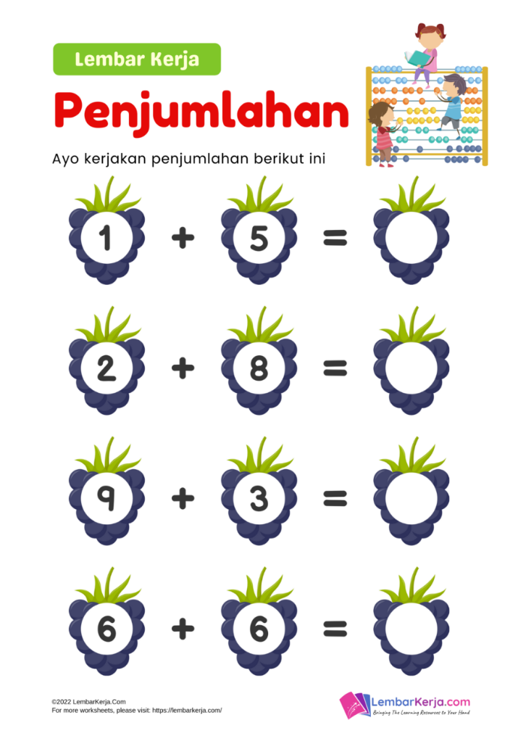

2. …+ 5 = 11 bilangan untuk mengisi titik-titik disamping adalah ……………
3. Pasangan bilangan 8 yang hasil penjumlahannya 15 adalah ………………..
4. 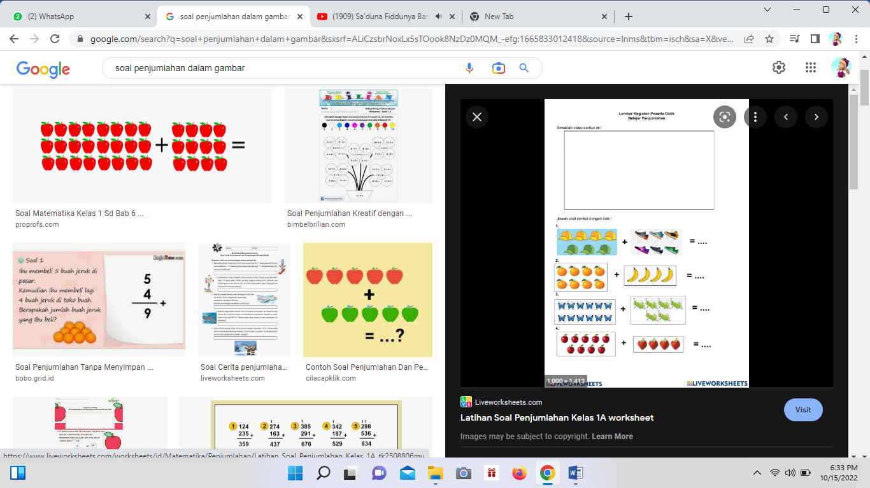Penjumlahan yang hasilnya 10 adalah ……… dan ………

1. ………
2. Ada 7 buah apel. Banyak pir 2 lebihnya dari apel. Banyak pir ada ………
3. Ida memelihara 7, sapi lalu sapi itu beranak 4. Jumlah sapi Ida sekarang ada ….
4. Topi Ira ada 6. Topi indah ada 7. Jumlah topi mereka ada ……………………………….

Kunci Jawaban : 1. 6 6. 5 dan 5

2. 6 7. 12

3. 12 8. 9

4. 6 9. 11

5.7 10 13

Penilaian : Benar X 10 = 100

Disupervisi tanggal ………… Tenggerwetan, ………….2023

Mengetahui

Pengawas Sekolah TK, SD, SDLB Kepala Sekolah Guru Kelas I (Satu)





**JATMIKA, S.Pd** **IMAM MURDIYANTO, S.Pd.SD** **RATNA WAHYUNI, S.Pd**

NIP. 19640416 198504 1 1002 NIP. 19801014 200801 1 009 NIP. 19851021 201903 2 006

**ANALISIS SUMATIF LINGKUP MATERI**

Mata Pelajaran : Matematika Ulangan Ke : 4

Bab : 4. Penjumlahan Hari / tanggal :

Jumlah Soal : 10 Soal Kelas / Semester : I (Satu) / I (Satu)

|  |  |  |  |  |  |  |  |  |  |  |  |  |
| --- | --- | --- | --- | --- | --- | --- | --- | --- | --- | --- | --- | --- |
| **NO** | **NAMA SISWA** | **BUTIR SOAL ISIAN** | | | | | | | | | | **NILAI TUJUAN PEMBELAJARAN** |
| 1 | 2 | 3 | 4 | 5 | 6 | 7 | 8 | 9 | 10 |
| 1. | Ahmad Beryl Subkan | 1 | 1 | 1 | 1 | 1 | 1 | 1 | 1 | 1 | 0 | 90 |
| 2. | Ahmad Izam Alhamdan | 1 | 1 | 1 | 1 | 0 | 1 | 1 | 1 | 1 | 0 | 80 |
| 3. | Anda Gian Pratama | 1 | 1 | 1 | 1 | 1 | 1 | 1 | 0 | 1 | 0 | 80 |
| 4. | Aulia Beby | 1 | 1 | 1 | 1 | 1 | 1 | 1 | 1 | 1 | 0 | 90 |
| 5. | Erdiano Utama | 1 | 1 | 1 | 1 | 1 | 1 | 1 | 0 | 1 | 0 | 80 |
| 6. | Hanafi Adam Pratama | 1 | 1 | 1 | 1 | 1 | 1 | 0 | 1 | 1 | 0 | 80 |
| 7. | Jefi Alif Febbiyanti | 0 | 1 | 1 | 1 | 1 | 0 | 1 | 1 | 1 | 0 | 70 |
| 8. | Jumfikri | 1 | 0 | 1 | 1 | 1 | 1 | 1 | 1 | 1 | 0 | 80 |
| 9. | Lisa Aktanesia | 1 | 1 | 1 | 1 | 1 | 1 | 0 | 1 | 1 | 0 | 80 |
| 10. | Mohamad Daril Adikri | 1 | 1 | 1 | 1 | 1 | 1 | 1 | 1 | 1 | 0 | 90 |
| 11. | Mohamad Robil Alamaulil | 1 | 1 | 1 | 1 | 1 | 1 | 1 | 0 | 1 | 0 | 80 |
| 12. | Muhammad Justin Gilbert | 1 | 1 | 1 | 1 | 1 | 1 | 0 | 1 | 0 | 0 | 70 |
| 13. | Nova Italia | 1 | 1 | 1 | 1 | 1 | 0 | 1 | 1 | 1 | 0 | 80 |
| 14. | Rafila Firda Ferdiyansah | 1 | 1 | 1 | 1 | 1 | 1 | 0 | 1 | 1 | 0 | 80 |
| 15. | Redi Fransisko | 1 | 1 | 0 | 1 | 0 | 1 | 1 | 1 | 1 | 0 | 70 |
| 16. | Rif’an Febrianto | 1 | 0 | 1 | 1 | 1 | 1 | 1 | 0 | 1 | 0 | 70 |
| 17. | Roef Ahmat Firmansyah | 0 | 1 | 1 | 0 | 1 | 1 | 1 | 1 | 1 | 0 | 70 |
| 18. | Sabilal Khoir | 1 | 1 | 1 | 1 | 1 | 1 | 1 | 1 | 1 | 0 | 90 |
| 19. | Selvi | 1 | 0 | 1 | 1 | 1 | 0 | 1 | 1 | 1 | 0 | 70 |
| 20. | Siti Aisah | 1 | 1 | 1 | 0 | 1 | 1 | 0 | 1 | 1 | 0 | 70 |
| 21. | Ummi Kulsum | 1 | 1 | 1 | 1 | 1 | 1 | 1 | 0 | 1 | 0 | 80 |
| 22. | Verdiano Elvan Alteza | 1 | 1 | 1 | 1 | 0 | 1 | 1 | 1 | 1 | 0 | 80 |
| 23. | Willi Febriyo | 1 | 1 | 1 | 1 | 1 | 1 | 0 | 1 | 1 | 0 | 80 |
| 24 | Willona Selsa Putri | 1 | 1 | 1 | 1 | 1 | 1 | 1 | 1 | 1 | 0 | 90 |



Tenggerwetan, ………….2023

Mengetahui

Kepala Sekolah Guru Kelas I (Satu)

**IMAM MURDIYANTO, S.Pd.SD** **RATNA WAHYUNI, S.Pd**

NIP. 19801014 200801 1 009 NIP. 19851021 201903 2 006

**LEMBAR TINDAK LANJUT HASIL PENILAIAN DAN JENIS TES : ULANGAN PERBAIKAN**

Mata Pelajaran : Matematika Ulangan Ke : 4

Bab : 4. Penjumlahan Hari / tanggal :

Jumlah Soal : 10 Soal Kelas / Semester : I (Satu) / I (Satu)

|  |  |  |  |  |  |  |  |  |  |  |  |  |
| --- | --- | --- | --- | --- | --- | --- | --- | --- | --- | --- | --- | --- |
| **NO** | **NAMA SISWA** | **BUTIR SOAL ISIAN** | | | | | | | | | | **NILAI TUJUAN PEMBELAJARAN** |
| 1 | 2 | 3 | 4 | 5 | 6 | 7 | 8 | 9 | 10 |
| 1. | Ahmad Beryl Subkan |  |  |  |  |  |  |  |  |  |  |  |
| 2. | Ahmad Izam Alhamdan |  |  |  |  |  |  |  |  |  |  |  |
| 3. | Anda Gian Pratama |  |  |  |  |  |  |  |  |  |  |  |
| 4. | Aulia Beby |  |  |  |  |  |  |  |  |  |  |  |
| 5. | Erdiano Utama |  |  |  |  |  |  |  |  |  |  |  |
| 6. | Hanafi Adam Pratama |  |  |  |  |  |  |  |  |  |  |  |
| 7. | Jefi Alif Febbiyanti |  |  |  |  |  |  |  |  |  |  |  |
| 8. | Jumfikri |  |  |  |  |  |  |  |  |  |  |  |
| 9. | Lisa Aktanesia |  |  |  |  |  |  |  |  |  |  |  |
| 10. | Mohamad Daril Adikri |  |  |  |  |  |  |  |  |  |  |  |
| 11. | Mohamad Robil Alamaulil |  |  |  |  |  |  |  |  |  |  |  |
| 12. | Muhammad Justin Gilbert |  |  |  |  |  |  |  |  |  |  |  |
| 13. | Nova Italia |  |  |  |  |  |  |  |  |  |  |  |
| 14. | Rafila Firda Ferdiyansah |  |  |  |  |  |  |  |  |  |  |  |
| 15. | Redi Fransisko |  |  |  |  |  |  |  |  |  |  |  |
| 16. | Rif’an Febrianto |  |  |  |  |  |  |  |  |  |  |  |
| 17. | Roef Ahmat Firmansyah |  |  |  |  |  |  |  |  |  |  |  |
| 18. | Sabilal Khoir |  |  |  |  |  |  |  |  |  |  |  |
| 19. | Selvi |  |  |  |  |  |  |  |  |  |  |  |
| 20. | Siti Aisah |  |  |  |  |  |  |  |  |  |  |  |
| 21. | Ummi Kulsum |  |  |  |  |  |  |  |  |  |  |  |
| 22. | Verdiano Elvan Alteza |  |  |  |  |  |  |  |  |  |  |  |
| 23. | Willi Febriyo |  |  |  |  |  |  |  |  |  |  |  |
| 24 | Willona Selsa Putri |  | E:\FILE RATNA-ZIE\SCAN TTD + STEMPEL.png |  |  |  |  |  |  |  |  |  |

Mengetahui : Mengetahui :

Pengawas Sekolah TK, SD, SDLB Kepala Sekolah Guru Kelas I (Satu)

**JATMIKA, S.Pd** **IMAM MURDIYANTO, S.Pd.SD** **RATNA WAHYUNI, S.Pd**

NIP. 19640416 198504 1 1002 NIP. 19801014 200801 1 009 NIP. 19851021 201903 2 006

**LEMBAR TINDAK LANJUT HASIL PENILAIAN DAN JENIS TES : ULANGAN PENGAYAAN**

Mata Pelajaran : Matematika Ulangan Ke : 4

Bab : 4. Penjumlahan Hari / tanggal :

Jumlah Soal : 10 Soal Kelas / Semester : I (Satu) / I (Satu)

|  |  |  |  |  |  |  |  |  |  |  |  |  |
| --- | --- | --- | --- | --- | --- | --- | --- | --- | --- | --- | --- | --- |
| **NO** | **NAMA SISWA** | **BUTIR SOAL ISIAN** | | | | | | | | | | **NILAI TUJUAN PEMBELAJARAN** |
| 1 | 2 | 3 | 4 | 5 | 6 | 7 | 8 | 9 | 10 |
| 1. | Ahmad Beryl Subkan |  |  |  |  |  |  |  |  |  |  |  |
| 2. | Ahmad Izam Alhamdan |  |  |  |  |  |  |  |  |  |  |  |
| 3. | Anda Gian Pratama |  |  |  |  |  |  |  |  |  |  |  |
| 4. | Aulia Beby |  |  |  |  |  |  |  |  |  |  |  |
| 5. | Erdiano Utama |  |  |  |  |  |  |  |  |  |  |  |
| 6. | Hanafi Adam Pratama |  |  |  |  |  |  |  |  |  |  |  |
| 7. | Jefi Alif Febbiyanti |  |  |  |  |  |  |  |  |  |  |  |
| 8. | Jumfikri |  |  |  |  |  |  |  |  |  |  |  |
| 9. | Lisa Aktanesia |  |  |  |  |  |  |  |  |  |  |  |
| 10. | Mohamad Daril Adikri |  |  |  |  |  |  |  |  |  |  |  |
| 11. | Mohamad Robil Alamaulil |  |  |  |  |  |  |  |  |  |  |  |
| 12. | Muhammad Justin Gilbert |  |  |  |  |  |  |  |  |  |  |  |
| 13. | Nova Italia |  |  |  |  |  |  |  |  |  |  |  |
| 14. | Rafila Firda Ferdiyansah |  |  |  |  |  |  |  |  |  |  |  |
| 15. | Redi Fransisko |  |  |  |  |  |  |  |  |  |  |  |
| 16. | Rif’an Febrianto |  |  |  |  |  |  |  |  |  |  |  |
| 17. | Roef Ahmat Firmansyah |  |  |  |  |  |  |  |  |  |  |  |
| 18. | Sabilal Khoir |  |  |  |  |  |  |  |  |  |  |  |
| 19. | Selvi |  |  |  |  |  |  |  |  |  |  |  |
| 20. | Siti Aisah |  |  |  |  |  |  |  |  |  |  |  |
| 21. | Ummi Kulsum |  |  |  |  |  |  |  |  |  |  |  |
| 22. | Verdiano Elvan Alteza |  |  |  |  |  |  |  |  |  |  |  |
| 23. | Willi Febriyo |  |  |  |  |  |  |  |  |  |  |  |
| 24 | Willona Selsa Putri |  |  |  |  |  |  |  |  |  |  |  |



Mengetahui : Mengetahui :

Pengawas Sekolah TK, SD, SDLB Kepala Sekolah Guru Kelas I (Satu)



**JATMIKA, S.Pd** **IMAM MURDIYANTO, S.Pd.SD** **RATNA WAHYUNI, S.Pd**

NIP. 19640416 198504 1 1002 NIP. 19801014 200801 1 009 NIP. 19851021 201903 2 006

**LEMBAR SOAL TEST TULIS HARIAN**

Mata Pelajaran : Matematika Ulangan Ke : 5

Bab : 5. Pengurangan Hari / tanggal :

Jumlah Soal : 10 Soal Kelas / Semester : I (Satu) / I (Satu)

Isilah titik-titik dibawah ini dengan jawaban yang benar!

1. Sebuah bilangan apabila dikurangi hasilnya semakin ………………………
2. Hasil dari 10 – 7 adalah ………………………….
3. 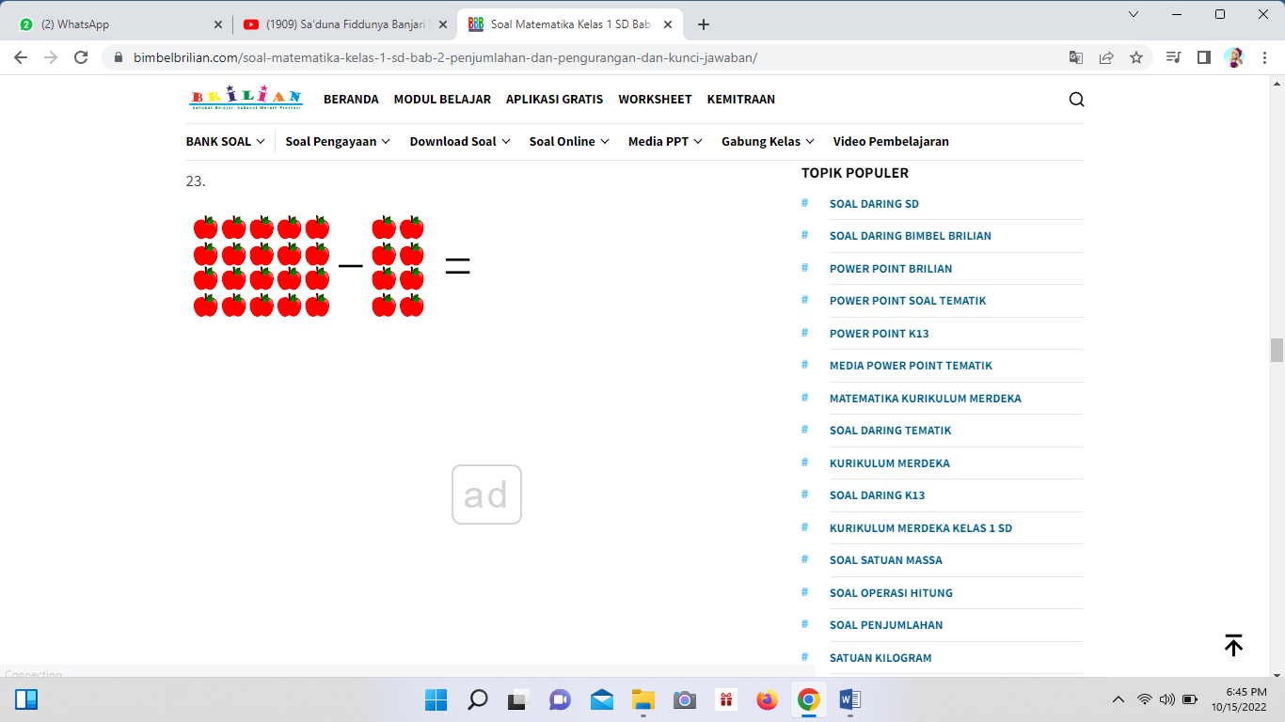 …………………………
4. 14 - … = 9 Bilangan untuk mengisi titik-titik disamping adalah ……………..
5. Selisih dari 6 dan 4 adalah ……………………….
6. 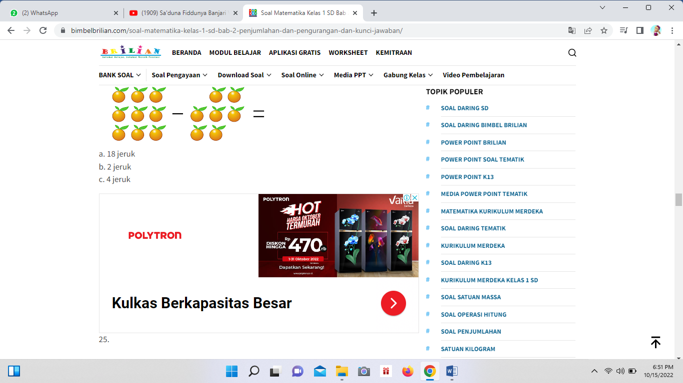16 – 10 = …………………..

1. ………
2. Ibu menanam bunga mawar 8 namun layu 3. Bunga mawar Ibu tinggal …………
3. Ikan di aquarium ada 9 namun lompat 2. Sekarang ikannya masih ……………
4. Adik dikasih kue 7, dikasih kakak 3. Kue kakak sekarang ada …………………

Kunci Jawaban : 1. sedikit 6. 6

2. 3 7. 1

3. 6 8. 5

4. 5 9. 7

5. 2 10 4

Penilaian : Benar X 10 = 100

Disupervisi tanggal ………… Tenggerwetan, ………….2023

Mengetahui

Pengawas Sekolah TK, SD, SDLB Kepala Sekolah Guru Kelas I (Satu)



**JATMIKA, S.Pd** **IMAM MURDIYANTO, S.Pd.SD** **RATNA WAHYUNI, S.Pd**

NIP. 19640416 198504 1 1002 NIP. 19801014 200801 1 009 NIP. 19851021 201903 2 006

**ANALISIS SUMATIF LINGKUP MATERI**

Mata Pelajaran : Matematika Ulangan Ke : 5

Bab : 5. Pengurangan Hari / tanggal :

Jumlah Soal : 10 Soal Kelas / Semester : I (Satu) / I (Satu)

|  |  |  |  |  |  |  |  |  |  |  |  |  |
| --- | --- | --- | --- | --- | --- | --- | --- | --- | --- | --- | --- | --- |
| **NO** | **NAMA SISWA** | **BUTIR SOAL ISIAN** | | | | | | | | | | **NILAI TUJUAN PEMBELAJARAN** |
| 1 | 2 | 3 | 4 | 5 | 6 | 7 | 8 | 9 | 10 |
| 1. | Ahmad Beryl Subkan | 1 | 1 | 1 | 1 | 1 | 1 | 1 | 1 | 1 | 1 | 100 |
| 2. | Ahmad Izam Alhamdan | 1 | 1 | 1 | 1 | 0 | 1 | 1 | 1 | 1 | 0 | 80 |
| 3. | Anda Gian Pratama | 1 | 1 | 1 | 1 | 1 | 1 | 1 | 0 | 1 | 0 | 80 |
| 4. | Aulia Beby | 1 | 1 | 1 | 1 | 1 | 1 | 1 | 1 | 1 | 0 | 90 |
| 5. | Erdiano Utama | 1 | 1 | 1 | 1 | 1 | 1 | 1 | 0 | 1 | 0 | 80 |
| 6. | Hanafi Adam Pratama | 1 | 1 | 1 | 1 | 1 | 1 | 0 | 1 | 1 | 0 | 80 |
| 7. | Jefi Alif Febbiyanti | 0 | 1 | 1 | 1 | 1 | 0 | 1 | 1 | 1 | 0 | 70 |
| 8. | Jumfikri | 1 | 0 | 1 | 1 | 1 | 1 | 1 | 1 | 1 | 0 | 80 |
| 9. | Lisa Aktanesia | 1 | 1 | 1 | 1 | 1 | 1 | 0 | 1 | 1 | 0 | 80 |
| 10. | Mohamad Daril Adikri | 1 | 1 | 1 | 1 | 1 | 1 | 1 | 1 | 1 | 1 | 100 |
| 11. | Mohamad Robil Alamaulil | 1 | 1 | 1 | 1 | 1 | 1 | 1 | 0 | 1 | 0 | 80 |
| 12. | Muhammad Justin Gilbert | 1 | 1 | 1 | 1 | 1 | 1 | 0 | 1 | 0 | 0 | 70 |
| 13. | Nova Italia | 1 | 1 | 1 | 1 | 1 | 0 | 1 | 1 | 1 | 0 | 80 |
| 14. | Rafila Firda Ferdiyansah | 1 | 1 | 1 | 1 | 1 | 1 | 0 | 1 | 1 | 0 | 80 |
| 15. | Redi Fransisko | 1 | 1 | 0 | 1 | 0 | 1 | 1 | 1 | 1 | 0 | 70 |
| 16. | Rif’an Febrianto | 1 | 0 | 1 | 1 | 1 | 1 | 1 | 0 | 1 | 0 | 70 |
| 17. | Roef Ahmat Firmansyah | 0 | 1 | 1 | 0 | 1 | 1 | 1 | 1 | 1 | 0 | 70 |
| 18. | Sabilal Khoir | 1 | 1 | 1 | 1 | 1 | 1 | 1 | 1 | 1 | 1 | 100 |
| 19. | Selvi | 1 | 0 | 1 | 1 | 1 | 0 | 1 | 1 | 1 | 0 | 70 |
| 20. | Siti Aisah | 1 | 1 | 1 | 0 | 1 | 1 | 0 | 1 | 1 | 0 | 70 |
| 21. | Ummi Kulsum | 1 | 1 | 1 | 1 | 1 | 1 | 1 | 0 | 1 | 0 | 80 |
| 22. | Verdiano Elvan Alteza | 1 | 1 | 1 | 1 | 0 | 1 | 1 | 1 | 1 | 0 | 80 |
| 23. | Willi Febriyo | 1 | 1 | 1 | 1 | 1 | 1 | 0 | 1 | 1 | 0 | 80 |
| 24 | Willona Selsa Putri | 1 | 1 | 1 | 1 | 1 | 1 | 1 | 1 | 1 | 1 | 100 |



Tenggerwetan, ………….2023

Mengetahui

Kepala Sekolah Guru Kelas I (Satu)

**IMAM MURDIYANTO, S.Pd.SD** **RATNA WAHYUNI, S.Pd**

NIP. 19801014 200801 1 009 NIP. 19851021 201903 2 006

**LEMBAR TINDAK LANJUT HASIL PENILAIAN DAN JENIS TES : ULANGAN PERBAIKAN**

Mata Pelajaran : Matematika Ulangan Ke : 5

Bab : 5. Pengurangan Hari / tanggal :

Jumlah Soal : 10 Soal Kelas / Semester : I (Satu) / I (Satu)

|  |  |  |  |  |  |  |  |  |  |  |  |  |
| --- | --- | --- | --- | --- | --- | --- | --- | --- | --- | --- | --- | --- |
| **NO** | **NAMA SISWA** | **BUTIR SOAL ISIAN** | | | | | | | | | | **NILAI TUJUAN PEMBELAJARAN** |
| 1 | 2 | 3 | 4 | 5 | 6 | 7 | 8 | 9 | 10 |
| 1. | Ahmad Beryl Subkan |  |  |  |  |  |  |  |  |  |  |  |
| 2. | Ahmad Izam Alhamdan |  |  |  |  |  |  |  |  |  |  |  |
| 3. | Anda Gian Pratama |  |  |  |  |  |  |  |  |  |  |  |
| 4. | Aulia Beby |  |  |  |  |  |  |  |  |  |  |  |
| 5. | Erdiano Utama |  |  |  |  |  |  |  |  |  |  |  |
| 6. | Hanafi Adam Pratama |  |  |  |  |  |  |  |  |  |  |  |
| 7. | Jefi Alif Febbiyanti |  |  |  |  |  |  |  |  |  |  |  |
| 8. | Jumfikri |  |  |  |  |  |  |  |  |  |  |  |
| 9. | Lisa Aktanesia |  |  |  |  |  |  |  |  |  |  |  |
| 10. | Mohamad Daril Adikri |  |  |  |  |  |  |  |  |  |  |  |
| 11. | Mohamad Robil Alamaulil |  |  |  |  |  |  |  |  |  |  |  |
| 12. | Muhammad Justin Gilbert |  |  |  |  |  |  |  |  |  |  |  |
| 13. | Nova Italia |  |  |  |  |  |  |  |  |  |  |  |
| 14. | Rafila Firda Ferdiyansah |  |  |  |  |  |  |  |  |  |  |  |
| 15. | Redi Fransisko |  |  |  |  |  |  |  |  |  |  |  |
| 16. | Rif’an Febrianto |  |  |  |  |  |  |  |  |  |  |  |
| 17. | Roef Ahmat Firmansyah |  |  |  |  |  |  |  |  |  |  |  |
| 18. | Sabilal Khoir |  |  |  |  |  |  |  |  |  |  |  |
| 19. | Selvi |  |  |  |  |  |  |  |  |  |  |  |
| 20. | Siti Aisah |  |  |  |  |  |  |  |  |  |  |  |
| 21. | Ummi Kulsum |  |  |  |  |  |  |  |  |  |  |  |
| 22. | Verdiano Elvan Alteza |  |  |  |  |  |  |  |  |  |  |  |
| 23. | Willi Febriyo |  |  |  |  |  |  |  |  |  |  |  |
| 24 | Willona Selsa Putri |  | E:\FILE RATNA-ZIE\SCAN TTD + STEMPEL.png |  |  |  |  |  |  |  |  |  |

Mengetahui : Mengetahui :

Pengawas Sekolah TK, SD, SDLB Kepala Sekolah Guru Kelas I (Satu)

**JATMIKA, S.Pd** **IMAM MURDIYANTO, S.Pd.SD** **RATNA WAHYUNI, S.Pd**

NIP. 19640416 198504 1 1002 NIP. 19801014 200801 1 009 NIP. 19851021 201903 2 006

**LEMBAR TINDAK LANJUT HASIL PENILAIAN DAN JENIS TES : ULANGAN PENGAYAAN**

Mata Pelajaran : Matematika Ulangan Ke : 5

Bab : 5. Pengurangan Hari / tanggal :

Jumlah Soal : 10 Soal Kelas / Semester : I (Satu) / I (Satu)

|  |  |  |  |  |  |  |  |  |  |  |  |  |
| --- | --- | --- | --- | --- | --- | --- | --- | --- | --- | --- | --- | --- |
| **NO** | **NAMA SISWA** | **BUTIR SOAL ISIAN** | | | | | | | | | | **NILAI TUJUAN PEMBELAJARAN** |
| 1 | 2 | 3 | 4 | 5 | 6 | 7 | 8 | 9 | 10 |
| 1. | Ahmad Beryl Subkan |  |  |  |  |  |  |  |  |  |  |  |
| 2. | Ahmad Izam Alhamdan |  |  |  |  |  |  |  |  |  |  |  |
| 3. | Anda Gian Pratama |  |  |  |  |  |  |  |  |  |  |  |
| 4. | Aulia Beby |  |  |  |  |  |  |  |  |  |  |  |
| 5. | Erdiano Utama |  |  |  |  |  |  |  |  |  |  |  |
| 6. | Hanafi Adam Pratama |  |  |  |  |  |  |  |  |  |  |  |
| 7. | Jefi Alif Febbiyanti |  |  |  |  |  |  |  |  |  |  |  |
| 8. | Jumfikri |  |  |  |  |  |  |  |  |  |  |  |
| 9. | Lisa Aktanesia |  |  |  |  |  |  |  |  |  |  |  |
| 10. | Mohamad Daril Adikri |  |  |  |  |  |  |  |  |  |  |  |
| 11. | Mohamad Robil Alamaulil |  |  |  |  |  |  |  |  |  |  |  |
| 12. | Muhammad Justin Gilbert |  |  |  |  |  |  |  |  |  |  |  |
| 13. | Nova Italia |  |  |  |  |  |  |  |  |  |  |  |
| 14. | Rafila Firda Ferdiyansah |  |  |  |  |  |  |  |  |  |  |  |
| 15. | Redi Fransisko |  |  |  |  |  |  |  |  |  |  |  |
| 16. | Rif’an Febrianto |  |  |  |  |  |  |  |  |  |  |  |
| 17. | Roef Ahmat Firmansyah |  |  |  |  |  |  |  |  |  |  |  |
| 18. | Sabilal Khoir |  |  |  |  |  |  |  |  |  |  |  |
| 19. | Selvi |  |  |  |  |  |  |  |  |  |  |  |
| 20. | Siti Aisah |  |  |  |  |  |  |  |  |  |  |  |
| 21. | Ummi Kulsum |  |  |  |  |  |  |  |  |  |  |  |
| 22. | Verdiano Elvan Alteza |  |  |  |  |  |  |  |  |  |  |  |
| 23. | Willi Febriyo |  |  |  |  |  |  |  |  |  |  |  |
| 24 | Willona Selsa Putri |  | E:\FILE RATNA-ZIE\SCAN TTD + STEMPEL.png |  |  |  |  |  |  |  |  |  |

Mengetahui : Mengetahui :

Pengawas Sekolah TK, SD, SDLB Kepala Sekolah Guru Kelas I (Satu)

**JATMIKA, S.Pd** **IMAM MURDIYANTO, S.Pd.SD** **RATNA WAHYUNI, S.Pd**

NIP. 19640416 198504 1 1002 NIP. 19801014 200801 1 009 NIP. 19851021 201903 2 006

**LEMBAR SOAL TEST TULIS HARIAN**

Mata Pelajaran : Seni Rupa Ulangan Ke : 3

Bab : 3. Gerakan Hari / tanggal :

Jumlah Soal : 10 Soal Kelas / Semester : I (Satu) / I (Satu)

Isilah titik-titik dibawah ini dengan jawaban yang benar!

1. Ide menggambar garis bisa berasal dari ………………………
2. Tekanan kuat pada pensil menghasilkan garis ………………………….
3. 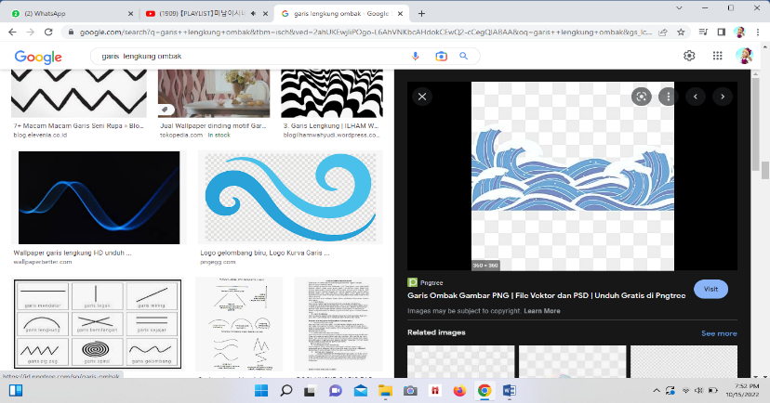 Gambar gulungan ombak disebut juga ………
4. Pusaran angina membentuk garis ……………..
5. Rambut lurus digambarkan dengan garis …………
6. Menggambar musik disesuaikan dengan ……………..

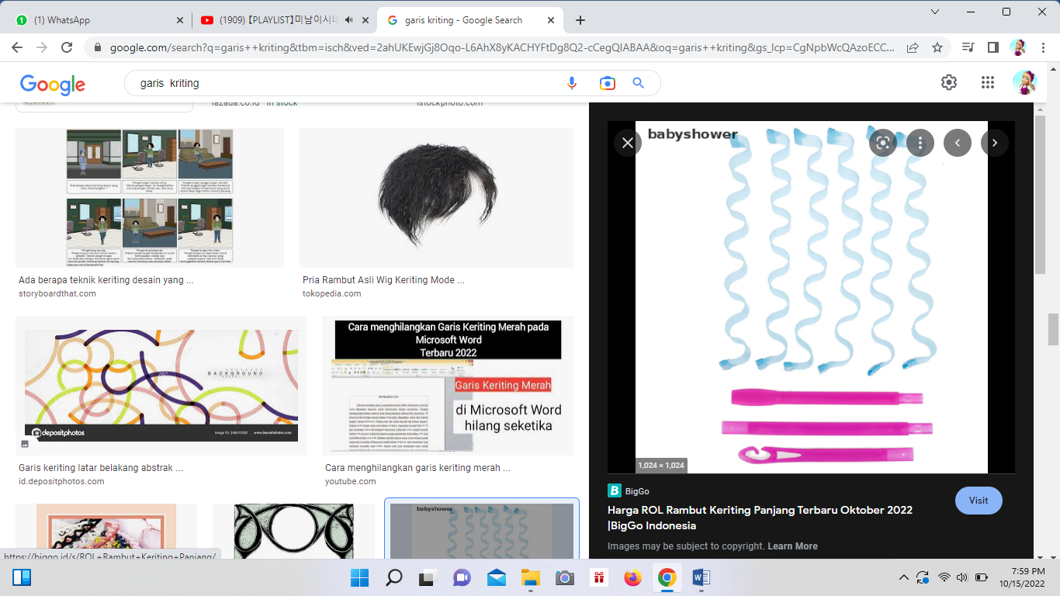

1. Garis bergelombang untuk rambut ………
2. Menggambar merupakan ungkapan …………
3. Garis patah-patah digunakan untuk menggambarkan musik ……………
4. Gerak kelinci melompat digambar dengan garis …………………

Kunci Jawaban : 1. Mana aja 6. irama

2. tebal 7. keriting

3. kurva 8. perasaan

4. ulir 9. cepat

5. vertikal 10 lengkung

Penilaian : Benar X 10 = 100

Disupervisi tanggal ………… Tenggerwetan, ………….2023

Mengetahui

Pengawas Sekolah TK, SD, SDLB Kepala Sekolah Guru Kelas I (Satu)



**JATMIKA, S.Pd** **IMAM MURDIYANTO, S.Pd.SD** **RATNA WAHYUNI, S.Pd**

NIP. 19640416 198504 1 1002 NIP. 19801014 200801 1 009 NIP. 19851021 201903 2 006

**ANALISIS SUMATIF LINGKUP MATERI**

Mata Pelajaran : Seni Rupa Ulangan Ke : 3

Bab : 3. Gerakan Hari / tanggal :

Jumlah Soal : 10 Soal Kelas / Semester : I (Satu) / I (Satu)

|  |  |  |  |  |  |  |  |  |  |  |  |  |
| --- | --- | --- | --- | --- | --- | --- | --- | --- | --- | --- | --- | --- |
| **NO** | **NAMA SISWA** | **BUTIR SOAL ISIAN** | | | | | | | | | | **NILAI TUJUAN PEMBELAJARAN** |
| 1 | 2 | 3 | 4 | 5 | 6 | 7 | 8 | 9 | 10 |
| 1. | Ahmad Beryl Subkan | 1 | 1 | 1 | 1 | 1 | 1 | 1 | 1 | 1 | 0 | 90 |
| 2. | Ahmad Izam Alhamdan | 1 | 1 | 1 | 1 | 0 | 1 | 1 | 1 | 1 | 0 | 80 |
| 3. | Anda Gian Pratama | 1 | 1 | 1 | 1 | 1 | 1 | 1 | 0 | 1 | 0 | 80 |
| 4. | Aulia Beby | 1 | 1 | 1 | 1 | 1 | 1 | 1 | 1 | 1 | 0 | 90 |
| 5. | Erdiano Utama | 1 | 1 | 1 | 1 | 1 | 1 | 1 | 0 | 1 | 0 | 80 |
| 6. | Hanafi Adam Pratama | 1 | 1 | 1 | 1 | 1 | 1 | 0 | 1 | 1 | 0 | 80 |
| 7. | Jefi Alif Febbiyanti | 0 | 1 | 1 | 1 | 1 | 0 | 1 | 1 | 1 | 0 | 70 |
| 8. | Jumfikri | 1 | 0 | 1 | 1 | 1 | 1 | 1 | 1 | 1 | 0 | 80 |
| 9. | Lisa Aktanesia | 1 | 1 | 1 | 1 | 1 | 1 | 0 | 1 | 1 | 0 | 80 |
| 10. | Mohamad Daril Adikri | 1 | 1 | 1 | 1 | 1 | 1 | 1 | 1 | 1 | 1 | 100 |
| 11. | Mohamad Robil Alamaulil | 1 | 1 | 1 | 1 | 1 | 1 | 1 | 0 | 1 | 0 | 80 |
| 12. | Muhammad Justin Gilbert | 1 | 1 | 1 | 1 | 1 | 1 | 0 | 1 | 0 | 0 | 70 |
| 13. | Nova Italia | 1 | 1 | 1 | 1 | 1 | 0 | 1 | 1 | 1 | 0 | 80 |
| 14. | Rafila Firda Ferdiyansah | 1 | 1 | 1 | 1 | 1 | 1 | 0 | 1 | 1 | 0 | 80 |
| 15. | Redi Fransisko | 1 | 1 | 0 | 1 | 0 | 1 | 1 | 1 | 1 | 0 | 70 |
| 16. | Rif’an Febrianto | 1 | 0 | 1 | 1 | 1 | 1 | 1 | 0 | 1 | 0 | 70 |
| 17. | Roef Ahmat Firmansyah | 0 | 1 | 1 | 0 | 1 | 1 | 1 | 1 | 1 | 0 | 70 |
| 18. | Sabilal Khoir | 1 | 1 | 1 | 1 | 1 | 1 | 1 | 1 | 1 | 0 | 90 |
| 19. | Selvi | 1 | 0 | 1 | 1 | 1 | 0 | 1 | 1 | 1 | 0 | 70 |
| 20. | Siti Aisah | 1 | 1 | 1 | 0 | 1 | 1 | 0 | 1 | 1 | 0 | 70 |
| 21. | Ummi Kulsum | 1 | 1 | 1 | 1 | 1 | 1 | 1 | 1 | 1 | 0 | 90 |
| 22. | Verdiano Elvan Alteza | 1 | 1 | 1 | 1 | 0 | 1 | 1 | 1 | 1 | 0 | 80 |
| 23. | Willi Febriyo | 1 | 1 | 1 | 1 | 1 | 1 | 0 | 1 | 1 | 0 | 80 |
| 24 | Willona Selsa Putri | 1 | 1 | 1 | 1 | 1 | 1 | 1 | 1 | 1 | 0 | 90 |



Tenggerwetan, ………….2023

Mengetahui

Kepala Sekolah Guru Kelas I (Satu)

**IMAM MURDIYANTO, S.Pd.SD** **RATNA WAHYUNI, S.Pd**

NIP. 19801014 200801 1 009 NIP. 19851021 201903 2 006

**LEMBAR TINDAK LANJUT HASIL PENILAIAN DAN JENIS TES : ULANGAN PERBAIKAN**

Mata Pelajaran : Seni Rupa Ulangan Ke : 3

Bab : 3. Gerakan Hari / tanggal :

Jumlah Soal : 10 Soal Kelas / Semester : I (Satu) / I (Satu)

|  |  |  |  |  |  |  |  |  |  |  |  |  |
| --- | --- | --- | --- | --- | --- | --- | --- | --- | --- | --- | --- | --- |
| **NO** | **NAMA SISWA** | **BUTIR SOAL ISIAN** | | | | | | | | | | **NILAI TUJUAN PEMBELAJARAN** |
| 1 | 2 | 3 | 4 | 5 | 6 | 7 | 8 | 9 | 10 |
| 1. | Ahmad Beryl Subkan |  |  |  |  |  |  |  |  |  |  |  |
| 2. | Ahmad Izam Alhamdan |  |  |  |  |  |  |  |  |  |  |  |
| 3. | Anda Gian Pratama |  |  |  |  |  |  |  |  |  |  |  |
| 4. | Aulia Beby |  |  |  |  |  |  |  |  |  |  |  |
| 5. | Erdiano Utama |  |  |  |  |  |  |  |  |  |  |  |
| 6. | Hanafi Adam Pratama |  |  |  |  |  |  |  |  |  |  |  |
| 7. | Jefi Alif Febbiyanti |  |  |  |  |  |  |  |  |  |  |  |
| 8. | Jumfikri |  |  |  |  |  |  |  |  |  |  |  |
| 9. | Lisa Aktanesia |  |  |  |  |  |  |  |  |  |  |  |
| 10. | Mohamad Daril Adikri |  |  |  |  |  |  |  |  |  |  |  |
| 11. | Mohamad Robil Alamaulil |  |  |  |  |  |  |  |  |  |  |  |
| 12. | Muhammad Justin Gilbert |  |  |  |  |  |  |  |  |  |  |  |
| 13. | Nova Italia |  |  |  |  |  |  |  |  |  |  |  |
| 14. | Rafila Firda Ferdiyansah |  |  |  |  |  |  |  |  |  |  |  |
| 15. | Redi Fransisko |  |  |  |  |  |  |  |  |  |  |  |
| 16. | Rif’an Febrianto |  |  |  |  |  |  |  |  |  |  |  |
| 17. | Roef Ahmat Firmansyah |  |  |  |  |  |  |  |  |  |  |  |
| 18. | Sabilal Khoir |  |  |  |  |  |  |  |  |  |  |  |
| 19. | Selvi |  |  |  |  |  |  |  |  |  |  |  |
| 20. | Siti Aisah |  |  |  |  |  |  |  |  |  |  |  |
| 21. | Ummi Kulsum |  |  |  |  |  |  |  |  |  |  |  |
| 22. | Verdiano Elvan Alteza |  |  |  |  |  |  |  |  |  |  |  |
| 23. | Willi Febriyo |  |  |  |  |  |  |  |  |  |  |  |
| 24 | Willona Selsa Putri |  | E:\FILE RATNA-ZIE\SCAN TTD + STEMPEL.png |  |  |  |  |  |  |  |  |  |

Mengetahui : Mengetahui :

Pengawas Sekolah TK, SD, SDLB Kepala Sekolah Guru Kelas I (Satu)

**JATMIKA, S.Pd** **IMAM MURDIYANTO, S.Pd.SD** **RATNA WAHYUNI, S.Pd**

NIP. 19640416 198504 1 1002 NIP. 19801014 200801 1 009 NIP. 19851021 201903 2 006

**LEMBAR TINDAK LANJUT HASIL PENILAIAN DAN JENIS TES : ULANGAN PENGAYAAN**

Mata Pelajaran : Seni Rupa Ulangan Ke : 3

Bab : 3. Gerakan Hari / tanggal :

Jumlah Soal : 10 Soal Kelas / Semester : I (Satu) / I (Satu)

|  |  |  |  |  |  |  |  |  |  |  |  |  |
| --- | --- | --- | --- | --- | --- | --- | --- | --- | --- | --- | --- | --- |
| **NO** | **NAMA SISWA** | **BUTIR SOAL ISIAN** | | | | | | | | | | **NILAI TUJUAN PEMBELAJARAN** |
| 1 | 2 | 3 | 4 | 5 | 6 | 7 | 8 | 9 | 10 |
| 1. | Ahmad Beryl Subkan |  |  |  |  |  |  |  |  |  |  |  |
| 2. | Ahmad Izam Alhamdan |  |  |  |  |  |  |  |  |  |  |  |
| 3. | Anda Gian Pratama |  |  |  |  |  |  |  |  |  |  |  |
| 4. | Aulia Beby |  |  |  |  |  |  |  |  |  |  |  |
| 5. | Erdiano Utama |  |  |  |  |  |  |  |  |  |  |  |
| 6. | Hanafi Adam Pratama |  |  |  |  |  |  |  |  |  |  |  |
| 7. | Jefi Alif Febbiyanti |  |  |  |  |  |  |  |  |  |  |  |
| 8. | Jumfikri |  |  |  |  |  |  |  |  |  |  |  |
| 9. | Lisa Aktanesia |  |  |  |  |  |  |  |  |  |  |  |
| 10. | Mohamad Daril Adikri |  |  |  |  |  |  |  |  |  |  |  |
| 11. | Mohamad Robil Alamaulil |  |  |  |  |  |  |  |  |  |  |  |
| 12. | Muhammad Justin Gilbert |  |  |  |  |  |  |  |  |  |  |  |
| 13. | Nova Italia |  |  |  |  |  |  |  |  |  |  |  |
| 14. | Rafila Firda Ferdiyansah |  |  |  |  |  |  |  |  |  |  |  |
| 15. | Redi Fransisko |  |  |  |  |  |  |  |  |  |  |  |
| 16. | Rif’an Febrianto |  |  |  |  |  |  |  |  |  |  |  |
| 17. | Roef Ahmat Firmansyah |  |  |  |  |  |  |  |  |  |  |  |
| 18. | Sabilal Khoir |  |  |  |  |  |  |  |  |  |  |  |
| 19. | Selvi |  |  |  |  |  |  |  |  |  |  |  |
| 20. | Siti Aisah |  |  |  |  |  |  |  |  |  |  |  |
| 21. | Ummi Kulsum |  |  |  |  |  |  |  |  |  |  |  |
| 22. | Verdiano Elvan Alteza |  |  |  |  |  |  |  |  |  |  |  |
| 23. | Willi Febriyo |  |  |  |  |  |  |  |  |  |  |  |
| 24 | Willona Selsa Putri |  | E:\FILE RATNA-ZIE\SCAN TTD + STEMPEL.png |  |  |  |  |  |  |  |  |  |

Mengetahui : Mengetahui :

Pengawas Sekolah TK, SD, SDLB Kepala Sekolah Guru Kelas I (Satu)

**JATMIKA, S.Pd** **IMAM MURDIYANTO, S.Pd.SD** **RATNA WAHYUNI, S.Pd**

NIP. 19640416 198504 1 1002 NIP. 19801014 200801 1 009 NIP.19851021 201903 2 006

**LEMBAR SOAL TEST TULIS HARIAN**

Mata Pelajaran : Seni Rupa Ulangan Ke : 4

Bab : 4. Bentuk Hari / tanggal :

Jumlah Soal : 10 Soal Kelas / Semester : I (Satu) / I (Satu)

Isilah titik-titik dibawah ini dengan jawaban yang benar!

1. Ide menggambar garis bisa berasal dari ………………………
2. Tekanan kuat pada pensil menghasilkan garis ………………………….
3.  Gambar gulungan ombak disebut juga ………
4. Pusaran angin membentuk garis ……………..
5. Rambut lurus digambarkan dengan garis …………
6. Menggambar musik disesuaikan dengan ……………..



1. Garis bergelombang untuk rambut ………
2. Menggambar merupakan ungkapan …………
3. Garis patah-patah digunakan untuk menggambarkan musik ……………
4. Gerak kelinci melompat digambar dengan garis …………………

Kunci Jawaban : 1. mana aja 6. irama

2. tebal 7. keriting

3. kurva 8. perasaan

4. ulir 9. cepat

5. vertikal 10 lengkung

Penilaian : Benar X 10 = 100

Disupervisi tanggal ………… Tenggerwetan, ………….2023

Mengetahui

Pengawas Sekolah TK, SD, SDLB Kepala Sekolah Guru Kelas I (Satu)



**JATMIKA, S.Pd** **IMAM MURDIYANTO, S.Pd.SD** **RATNA WAHYUNI, S.Pd**

NIP. 19640416 198504 1 1002 NIP. 19801014 200801 1 009 NIP. 19851021 201903 2 006

**ANALISIS SUMATIF LINGKUP MATERI**

Mata Pelajaran : Seni Rupa Ulangan Ke : 4

Bab : 4. Bentuk Hari / tanggal :

Jumlah Soal : 10 Soal Kelas / Semester : I (Satu) / I (Satu)

|  |  |  |  |  |  |  |  |  |  |  |  |  |
| --- | --- | --- | --- | --- | --- | --- | --- | --- | --- | --- | --- | --- |
| **NO** | **NAMA SISWA** | **BUTIR SOAL ISIAN** | | | | | | | | | | **NILAI TUJUAN PEMBELAJARAN** |
| 1 | 2 | 3 | 4 | 5 | 6 | 7 | 8 | 9 | 10 |
| 1. | Ahmad Beryl Subkan | 1 | 1 | 1 | 1 | 1 | 1 | 1 | 1 | 1 | 0 | 90 |
| 2. | Ahmad Izam Alhamdan | 1 | 1 | 1 | 1 | 0 | 1 | 1 | 1 | 1 | 0 | 80 |
| 3. | Anda Gian Pratama | 1 | 1 | 1 | 1 | 1 | 1 | 1 | 0 | 1 | 0 | 80 |
| 4. | Aulia Beby | 1 | 1 | 1 | 1 | 1 | 1 | 1 | 1 | 1 | 0 | 90 |
| 5. | Erdiano Utama | 1 | 1 | 1 | 1 | 1 | 1 | 1 | 0 | 1 | 0 | 80 |
| 6. | Hanafi Adam Pratama | 1 | 1 | 1 | 1 | 1 | 1 | 0 | 1 | 1 | 0 | 80 |
| 7. | Jefi Alif Febbiyanti | 0 | 1 | 1 | 1 | 1 | 0 | 1 | 1 | 1 | 0 | 70 |
| 8. | Jumfikri | 1 | 0 | 1 | 1 | 1 | 1 | 1 | 1 | 1 | 0 | 80 |
| 9. | Lisa Aktanesia | 1 | 1 | 1 | 1 | 1 | 1 | 0 | 1 | 1 | 0 | 80 |
| 10. | Mohamad Daril Adikri | 1 | 1 | 1 | 1 | 1 | 1 | 1 | 1 | 1 | 0 | 90 |
| 11. | Mohamad Robil Alamaulil | 1 | 1 | 1 | 1 | 1 | 1 | 1 | 0 | 1 | 0 | 80 |
| 12. | Muhammad Justin Gilbert | 1 | 1 | 1 | 1 | 1 | 1 | 0 | 1 | 0 | 0 | 70 |
| 13. | Nova Italia | 1 | 1 | 1 | 1 | 1 | 0 | 1 | 1 | 1 | 0 | 80 |
| 14. | Rafila Firda Ferdiyansah | 1 | 1 | 1 | 1 | 1 | 1 | 0 | 1 | 1 | 0 | 80 |
| 15. | Redi Fransisko | 1 | 1 | 0 | 1 | 0 | 1 | 1 | 1 | 1 | 0 | 70 |
| 16. | Rif’an Febrianto | 1 | 0 | 1 | 1 | 1 | 1 | 1 | 0 | 1 | 0 | 70 |
| 17. | Roef Ahmat Firmansyah | 0 | 1 | 1 | 0 | 1 | 1 | 1 | 1 | 1 | 0 | 70 |
| 18. | Sabilal Khoir | 1 | 1 | 1 | 1 | 1 | 1 | 1 | 1 | 1 | 0 | 90 |
| 19. | Selvi | 1 | 0 | 1 | 1 | 1 | 0 | 1 | 1 | 1 | 0 | 70 |
| 20. | Siti Aisah | 1 | 1 | 1 | 0 | 1 | 1 | 0 | 1 | 1 | 0 | 70 |
| 21. | Ummi Kulsum | 1 | 1 | 1 | 1 | 1 | 1 | 1 | 0 | 1 | 0 | 80 |
| 22. | Verdiano Elvan Alteza | 1 | 1 | 1 | 1 | 0 | 1 | 1 | 1 | 1 | 0 | 80 |
| 23. | Willi Febriyo | 1 | 1 | 1 | 1 | 1 | 1 | 0 | 1 | 1 | 0 | 80 |
| 24 | Willona Selsa Putri | 1 | 1 | 1 | 1 | 1 | 1 | 1 | 1 | 1 | 0 | 90 |

Tenggerwetan, ………….2023

Mengetahui

Kepala Sekolah Guru Kelas I (Satu)

**IMAM MURDIYANTO, S.Pd.SD** **RATNA WAHYUNI, S.Pd**

NIP. 19801014 200801 1 009 NIP. 19851021 201903 2 006

**LEMBAR TINDAK LANJUT HASIL PENILAIAN DAN JENIS TES : ULANGAN PERBAIKAN**

Mata Pelajaran : Seni Rupa Ulangan Ke : 4

Bab : 4. Bentuk Hari / tanggal :

Jumlah Soal : 10 Soal Kelas / Semester : I (Satu) / I (Satu)

|  |  |  |  |  |  |  |  |  |  |  |  |  |
| --- | --- | --- | --- | --- | --- | --- | --- | --- | --- | --- | --- | --- |
| **NO** | **NAMA SISWA** | **BUTIR SOAL ISIAN** | | | | | | | | | | **NILAI TUJUAN PEMBELAJARAN** |
| 1 | 2 | 3 | 4 | 5 | 6 | 7 | 8 | 9 | 10 |
| 1. | Ahmad Beryl Subkan |  |  |  |  |  |  |  |  |  |  |  |
| 2. | Ahmad Izam Alhamdan |  |  |  |  |  |  |  |  |  |  |  |
| 3. | Anda Gian Pratama |  |  |  |  |  |  |  |  |  |  |  |
| 4. | Aulia Beby |  |  |  |  |  |  |  |  |  |  |  |
| 5. | Erdiano Utama |  |  |  |  |  |  |  |  |  |  |  |
| 6. | Hanafi Adam Pratama |  |  |  |  |  |  |  |  |  |  |  |
| 7. | Jefi Alif Febbiyanti |  |  |  |  |  |  |  |  |  |  |  |
| 8. | Jumfikri |  |  |  |  |  |  |  |  |  |  |  |
| 9. | Lisa Aktanesia |  |  |  |  |  |  |  |  |  |  |  |
| 10. | Mohamad Daril Adikri |  |  |  |  |  |  |  |  |  |  |  |
| 11. | Mohamad Robil Alamaulil |  |  |  |  |  |  |  |  |  |  |  |
| 12. | Muhammad Justin Gilbert |  |  |  |  |  |  |  |  |  |  |  |
| 13. | Nova Italia |  |  |  |  |  |  |  |  |  |  |  |
| 14. | Rafila Firda Ferdiyansah |  |  |  |  |  |  |  |  |  |  |  |
| 15. | Redi Fransisko |  |  |  |  |  |  |  |  |  |  |  |
| 16. | Rif’an Febrianto |  |  |  |  |  |  |  |  |  |  |  |
| 17. | Roef Ahmat Firmansyah |  |  |  |  |  |  |  |  |  |  |  |
| 18. | Sabilal Khoir |  |  |  |  |  |  |  |  |  |  |  |
| 19. | Selvi |  |  |  |  |  |  |  |  |  |  |  |
| 20. | Siti Aisah |  |  |  |  |  |  |  |  |  |  |  |
| 21. | Ummi Kulsum |  |  |  |  |  |  |  |  |  |  |  |
| 22. | Verdiano Elvan Alteza |  |  |  |  |  |  |  |  |  |  |  |
| 23. | Willi Febriyo |  |  |  |  |  |  |  |  |  |  |  |
| 24 | Willona Selsa Putri |  | E:\FILE RATNA-ZIE\SCAN TTD + STEMPEL.png |  |  |  |  |  |  |  |  |  |

Mengetahui : Mengetahui :

Pengawas Sekolah TK, SD, SDLB Kepala Sekolah Guru Kelas I (Satu)

**JATMIKA, S.Pd** **IMAM MURDIYANTO, S.Pd.SD** **RATNA WAHYUNI, S.Pd**

NIP. 19640416 198504 1 1002 NIP. 19801014 200801 1 009 NIP. 19851021 201903 2 006

**LEMBAR TINDAK LANJUT HASIL PENILAIAN DAN JENIS TES : ULANGAN PENGAYAAN**

Mata Pelajaran : Seni Rupa Ulangan Ke : 4

Bab : 4. Bentuk Hari / tanggal :

Jumlah Soal : 10 Soal Kelas / Semester : I (Satu) / I (Satu)

|  |  |  |  |  |  |  |  |  |  |  |  |  |
| --- | --- | --- | --- | --- | --- | --- | --- | --- | --- | --- | --- | --- |
| **NO** | **NAMA SISWA** | **BUTIR SOAL ISIAN** | | | | | | | | | | **NILAI TUJUAN PEMBELAJARAN** |
| 1 | 2 | 3 | 4 | 5 | 6 | 7 | 8 | 9 | 10 |
| 1. | Ahmad Beryl Subkan |  |  |  |  |  |  |  |  |  |  |  |
| 2. | Ahmad Izam Alhamdan |  |  |  |  |  |  |  |  |  |  |  |
| 3. | Anda Gian Pratama |  |  |  |  |  |  |  |  |  |  |  |
| 4. | Aulia Beby |  |  |  |  |  |  |  |  |  |  |  |
| 5. | Erdiano Utama |  |  |  |  |  |  |  |  |  |  |  |
| 6. | Hanafi Adam Pratama |  |  |  |  |  |  |  |  |  |  |  |
| 7. | Jefi Alif Febbiyanti |  |  |  |  |  |  |  |  |  |  |  |
| 8. | Jumfikri |  |  |  |  |  |  |  |  |  |  |  |
| 9. | Lisa Aktanesia |  |  |  |  |  |  |  |  |  |  |  |
| 10. | Mohamad Daril Adikri |  |  |  |  |  |  |  |  |  |  |  |
| 11. | Mohamad Robil Alamaulil |  |  |  |  |  |  |  |  |  |  |  |
| 12. | Muhammad Justin Gilbert |  |  |  |  |  |  |  |  |  |  |  |
| 13. | Nova Italia |  |  |  |  |  |  |  |  |  |  |  |
| 14. | Rafila Firda Ferdiyansah |  |  |  |  |  |  |  |  |  |  |  |
| 15. | Redi Fransisko |  |  |  |  |  |  |  |  |  |  |  |
| 16. | Rif’an Febrianto |  |  |  |  |  |  |  |  |  |  |  |
| 17. | Roef Ahmat Firmansyah |  |  |  |  |  |  |  |  |  |  |  |
| 18. | Sabilal Khoir |  |  |  |  |  |  |  |  |  |  |  |
| 19. | Selvi |  |  |  |  |  |  |  |  |  |  |  |
| 20. | Siti Aisah |  |  |  |  |  |  |  |  |  |  |  |
| 21. | Ummi Kulsum |  |  |  |  |  |  |  |  |  |  |  |
| 22. | Verdiano Elvan Alteza |  |  |  |  |  |  |  |  |  |  |  |
| 23. | Willi Febriyo |  |  |  |  |  |  |  |  |  |  |  |
| 24 | Willona Selsa Putri |  | E:\FILE RATNA-ZIE\SCAN TTD + STEMPEL.png |  |  |  |  |  |  |  |  |  |

Mengetahui : Mengetahui :

Pengawas Sekolah TK, SD, SDLB Kepala Sekolah Guru Kelas I (Satu)

**JATMIKA, S.Pd** **IMAM MURDIYANTO, S.Pd.SD** **RATNA WAHYUNI, S.Pd**

NIP. 19640416 198504 1 1002 NIP. 19801014 200801 1 009 NIP. 19851021 201903 2 006